27.63: 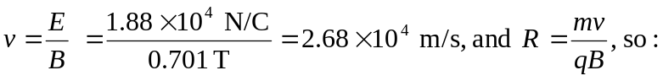
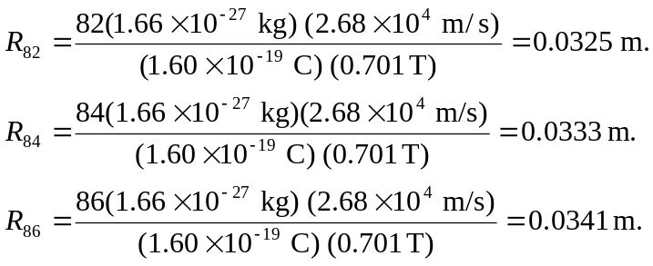
So the distance between two adjacent lines is 2R = 1.6 mm.

